Privilege Escalation Finding
SUID Misconfiguration in nmap — DVWA Command Execution Chain
Field | Detail
Author | Rohan
Date | 25/07/2025
Target Machine | DVWA / Metasploitable-style VM (192.168.100.20)
Attack Stage | Post-exploitation — Privilege Escalation
Preceding Vulnerability | Command Execution (DVWA) — used to obtain initial reverse shell as www-data

1. Background — What is SUID?
Every file on Linux has permissions controlling who can read, write, or execute it. A special extra permission called SUID (Set User ID) changes this behavior for executable programs.
Normal behavior (without SUID): When a program is run, it executes with the privileges of the user who launched it. A low-privilege account (such as www-data) running a program only has www-data's level of access.
With SUID set: The program instead runs with the privileges of whoever OWNS the file — regardless of who launched it. If a file is owned by root and has the SUID bit set, any user who executes it temporarily gains root-level power for that program's execution.
Why SUID exists: It is meant for narrow, controlled cases. For example, /usr/bin/passwd needs SUID because changing a password requires writing to a protected system file (/etc/shadow) that ordinary users cannot access directly. SUID lets passwd perform that one specific privileged task safely, without granting the user full root access.
The danger: SUID is only safe when the program was carefully designed to prevent the user from escaping into arbitrary command execution. Some tools — including older versions of nmap — were never designed with SUID safety in mind. If such a tool has any built-in feature that can spawn a shell or run other programs, and it has been given the SUID bit, that feature can be abused to gain root access.

2. Description

The target system had the SUID (Set User ID) permission bit set on /usr/bin/nmap. This misconfiguration causes nmap to execute with root-level privileges regardless of which user account runs it. Older versions of nmap include an interactive mode with a shell-escape shortcut (!sh), originally intended as a convenience feature. Because nmap itself was running as root due to the SUID bit, this shell-escape feature could be abused to spawn a fully privileged root shell.

Exploitation Steps

Enumerated SUID binaries on the system using find / -perm -4000 -type f 2>/dev/null

Identified /usr/bin/nmap in the results

Launched nmap's interactive mode: nmap --interactive

Executed the shell-escape command: !sh

Verified privilege level using whoami, confirming escalation from www-data to root

3. Step-by-Step — What nmap --interactive Actually Does
1. You run the command below. This starts nmap in a special mode where, instead of running a single scan and exiting, it opens a live prompt and waits for further input.
nmap –interactive

2. You type the shell-escape shortcut. The ! symbol tells nmap's interactive mode: "don't treat this as an nmap command — run this as a raw shell command instead." sh is the name of a basic Unix shell program (similar to bash, just simpler).
!sh

3. Internally, because nmap is currently running with root privileges (due to the SUID bit) and it is nmap that is spawning sh on the user's behalf, the new sh process it creates also runs as root. The user is dropped directly into this new root-level shell.

4. Confirm the escalation succeeded by checking the current user identity:
whoami
If this now prints root instead of www-data (the previous low-privilege account), privilege escalation from a low-privilege web account to full root control has been achieved.
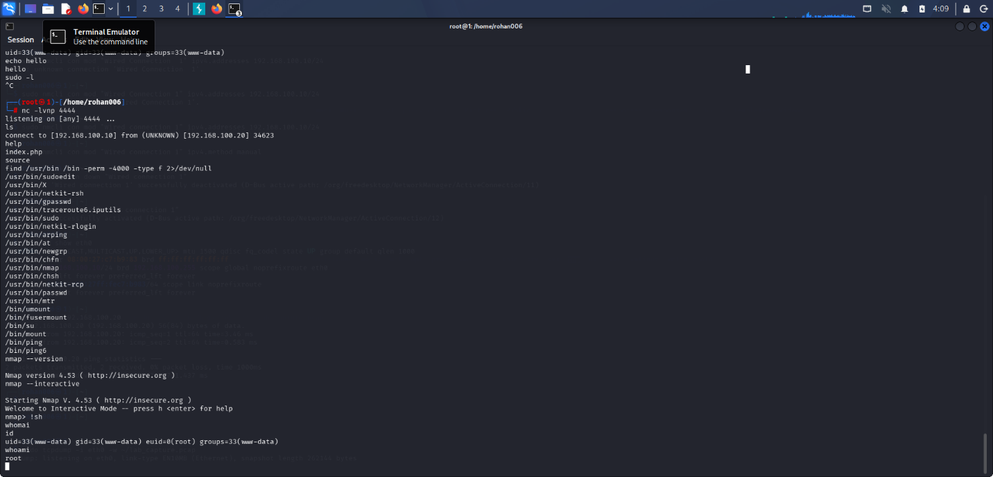

Impact
Complete compromise of the target system. An attacker who gained initial low-privilege access (e.g., via the SQL Injection or Command Execution vulnerabilities already documented) could use this SUID misconfiguration to obtain full administrative control, enabling arbitrary file access, user creation, malware installation, or persistent backdoors.

Root Cause
Unnecessary SUID permission granted to a binary (nmap) that does not require elevated privileges for its intended use case, combined with the binary's own legacy interactive/shell-escape functionality.

Remediation

Remove the SUID bit from nmap unless explicitly required: chmod u-s /usr/bin/nmap

Regularly audit all SUID binaries on production systems using find / -perm -4000 -type f

Apply the principle of least privilege: no binary should have elevated permissions beyond what its core function strictly requires

Keep software updated — modern nmap versions have removed the vulnerable interactive mode entirely

6. References
- GTFOBins — nmap entry (documents this exact technique)
- MITRE ATT&CK — T1548.001: Abuse Elevation Control Mechanism (Setuid and Setgid)
- MITRE ATT&CK — T1068: Exploitation for Privilege Escalation

